**COMPUTER SCIENCE DEPARTMENT**

**Total Marks:**

**Obtained Marks:**

LAB: Database System

# LAB TASK

**Submitted To: Mam Kashia Riaz Date of Submission: 23-December-2024**

# Ubaid Bin Waris

# 2212416

**University Database Sytem**

There are five table in the university Database System.

1. **Department Table**

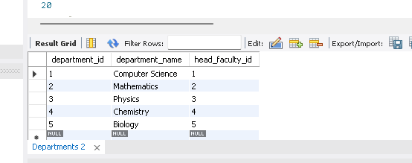

1. **Students Table**

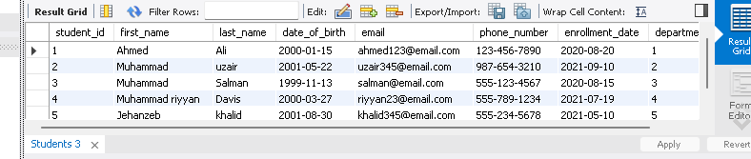

1. **Faculty Table**

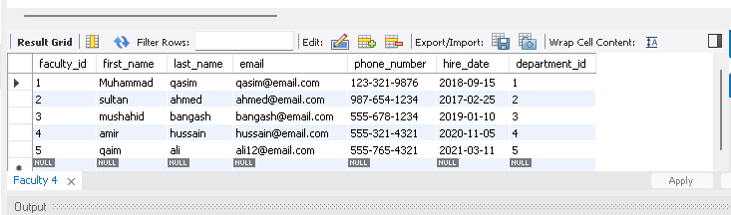

1. **Courses Table**

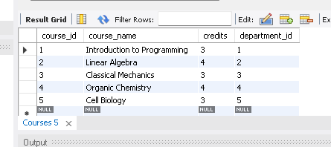

1. **Enrollments**

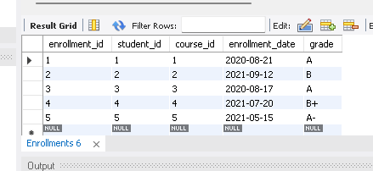

**5 Queries**

1. **Distinct Queries**

SELECT DISTINCT department_id

FROM Students;

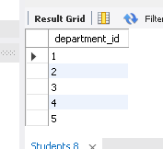

SELECT DISTINCT course_name

FROM Courses;

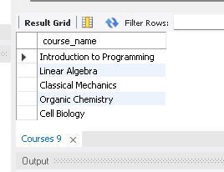

1. **Alter Queries**

ALTER TABLE Students

ADD COLUMN graduation_year INT;

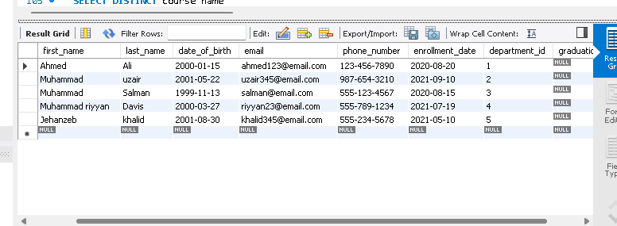

1. **Sub Queries**

SELECT first_name, last_name

FROM Faculty

WHERE department_id = (

SELECT department_id

FROM Departments

WHERE department_name = 'Computer Science'

);

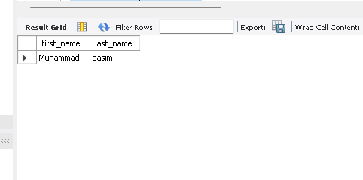

1. **Aggregate Queries**

SELECT MAX(grade) AS highest_grade

FROM Enrollments

WHERE course_id = (

SELECT course_id

FROM Courses

WHERE course_name = 'Organic Chemistry'

);

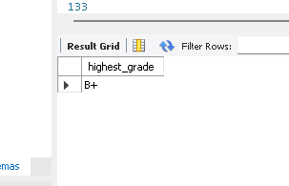

1. **Order by Queries**

SELECT first_name, last_name

FROM Faculty

ORDER BY last_name DESC;

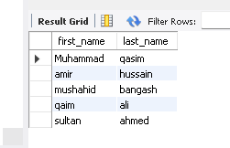

SELECT first_name, last_name

FROM Students

ORDER BY last_name ASC, first_name ASC;

